**Department of Mechanical Engineering**

**ME 222A**

**Nature and Properties of Material**



**Lab Report**

**Experiment No. : 4**

Studies on crack growth over cycles

Instructor: Dr Bishakh Battacharya

*Date of experiment: Jan 30, 2017*

*Date of submission Feb 6, 2017*

**Group – B2**

*150534 Pulkit Jain*

*150542 Puthawala Faisal*

*150545 Raghav Gupta*

*150546 Rahul Kumar*

*150552 Rahul Shekhar*

*150557 Rajesh Mishra*

*150558 Raj Kumar Meena*

**AIM OF THE EXPERIMENT**

* To study the crack growth characteristics of an elastomer under tension and compression cycles.
* To measure the crack length versus number of cycles, plot graph between them and analyse.

**INTRODUCTION**

Elastomers: They are amorphous polymers existing above their glass transition temperature, so that considerable segmental motion is possible. The use of elastomers in today’s life is indispensable. Some of their applications are sound absorbers, waterproofing materials etc. Due to their intensive use in the industries they are supposed to have a higher fatigue life so that they can last long and can be used for a longer time without replacement. Hence in order to achieve this elastomers undergo many fatigue tests. Elastomers often wear out due to development of cracks formed due to imposition of cyclic stresses.

Fatigue is a form of failure that occurs in structures subjected to dynamic and fluctuating stresses (e.g. bridges, aircrafts, machines etc.). Under these circumstances it is possible for failure to occur at a stress Level considerably lower than the tensile or yield strength for a static load. The term “fatigue” is used because this type of failure normally occurs after a lengthy period of repeated stress and strain cycling. Cyclic Stresses is the distribution of forces that change over time in a repetitive fashion. Fatigue failure is typically modelled by decomposing cyclic stresses into mean and alternating components. The process of fatigue failure is characterized by three distinct steps:

(1) Crack initiation, wherein a small crack forms at some point of high stress concentration;

(2) Crack propagation, during which this crack advances incrementally with each stress cycle; and

(3) Final failure, which occurs very rapidly once the advancing crack has reached a critical size.

**THEORY**

**Fatigue:** Fatigue is weakening of material because of cyclic loading. Fatigue is the weakening of a material caused by repeatedly applied loads. It is the progressive and localised structural damage that occurs when a material is subjected to cyclic loading.

**Fatigue Limit:** Fatigue limit is the maximum stress that can be applied to a material for which there is no failure.

**Fatigue strength:** The stress at which the material fails at a specified number of cycles is called the fatigue strength.

**Fatigue life:** The number of cycles at which the material fails at a specified stress is called Fatigue life.

**Crack Growth involves the following three processes:**

* **Crack Initiation:** Wherein some crack forms at some places where stress concentration is high.
* **Crack Propagation:** Wherein the crack grows incrementally with each stress cycle.
* **Final Failure:** When the crack reaches its critical stage, rapid failure occurs and material breaks.

Cracks associated with fatigue failure almost always initiate (or nucleate) on the surface of a component at some point of stress concentration.

Crack nucleation sites include surface scratches, sharp fillets, keyways,

threads, dents, and the like. In addition, cyclic loading can produce microscopic surface discontinuities resulting from dislocation slip steps that may also act as stress raisers, and therefore as crack initiation sites.

**The fatigue life cycle:** The number of cycles to which the material fails is given by N(f). The number of crack initiation cycles is given by N(i). The number of crack propagation cycles are given by N(p).

These are related by the relation-

**N (f) = N (i) + N (p)**

**MACHINE:**

Fatigue Testing Machine consists of horizontal plates between which we fix our material to be tested. The top plate is fixed which other plates are moved up and down with the help of a motor. The motor rotates a disk .A rod is connected to the disk near its periphery. The rotation of disk moves the rod which is connected to the horizontal plates and hence moves it up and down. In this way cyclic load is applied on the elastomer sample fixed in between the stationary top plate and movable bottom plates.

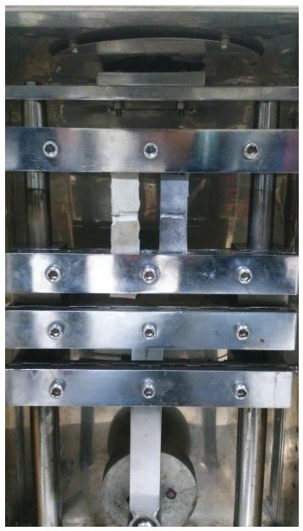

**SAMPLE:**

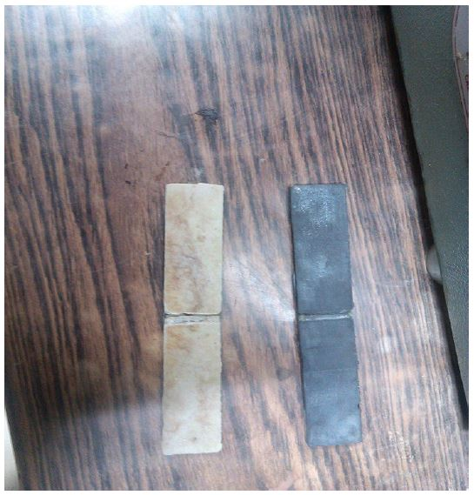

In the above figure the left one is natural rubber and the right one is synthetic rubber

**PROCEDURE**

* Measure the dimensions of the given Elastomer samples.
* Insert the elastomer sample tightly into the machine holder
* Switch on the fatigue testing machine and let it run for few cycles
* Measure the amount of growth of crack after a period of each 200 cycles and record it in the observation table
* Plot the required graph

**OBSERVATION TABLES AND GRAPHS**

The two rubber samples provided are

* Simple rubber having no carbon in its composition (easier to stretch with hands)
* Carbon mixed rubber (Stiffer to stretch with hands)

**Specimen specification**

|  |  |
| --- | --- |
| Synthetic Rubber | Notch Thickness  (mm) |
| Without Carbon | 4.40 |
| With Carbon | 4.02 |

**Observation table for rubber samples**

|  |  |  |  |
| --- | --- | --- | --- |
| S. No. | Number of Cycles | Crack Length  (without carbon)  (mm) | Crack Length  (with carbon)  (mm) |
| 1 | 500 | 0.00 | 0.00 |
| 2 | 1000 | 0.00 | 0.40 |
| 3 | 1300 | 0.00 | 2.28 |
| 4 | 1600 | 0.00 | 3.14 |
| 5 | 1700 | 0.00 | 3.54 |
| 6 | 1900 | 0.00 | 4.02 |
| 7 | 2400 | 0.38 |  |
| 8 | 2700 | 0.90 |  |
| 9 | 3000 | 1.58 |  |
| 10 | 3300 | 2.34 |  |
| 11 | 3500 | 2.88 |  |
| 12 | 3900 | 3.02 |  |
| 13 | 4300 | 3.60 |  |
| 14 | 4400 | 3.70 |  |
| 15 | 4500 | 3.72 |  |
| 16 | 4700 | 4.10 |  |
| 17 | 4800 | 4.40 |  |

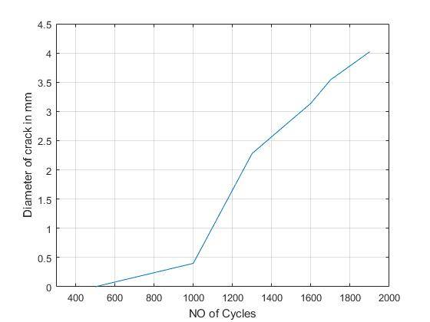

‘With Carbon’ Sample

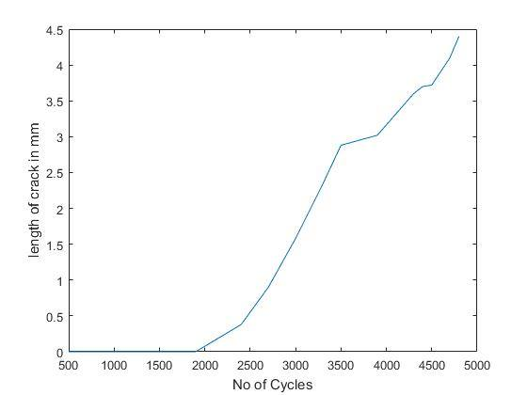

‘Without Carbon’ Sample

**Discussion**

Fatigue is catastrophic and insidious, occurring very suddenly and without warning. It is very important to study the fatigue behavior of material because it is larger cause of failure in metals.

It is necessary to do fatigue test or crack growth test of all materials in order to know cycles after with material will break. This will help to find best possible material for equipment which undergo cyclic load. Also this will help in reducing accidents during working of such equipment.

The process occurs by the initiation and propagation of cracks and usually the failure surface is perpendicular to the direction of applied tensile stress.

Failure is brittle like in nature even in normally ductile metals, in that there is very little, if any, gross plastic deformation associated with failure.

**RESULTS**

* Rubber sample without carbon content failed after 3200 cycles
* Rubber sample with carbon content failed after 2700 cycles

**Conclusion:-**

From the results it can be concluded that rubber sample without carbon content is better than rubber sample with carbon content while dealing with cyclic load.

**PRECAUTIONS**

* Handle the rubber samples carefully
* Do not stretch the samples with hand before testing as it may produce residual stress before the experiment
* Operate the machine carefully
* Switch off the machine while taking readings of sample
* Make sure to close the door of machine before starting it.
* Fix the sample properly between the plates.
* Make sure that both the rubber samples move in the same direction when applied cyclic load.

**Reference:**

* Wikipedia
* Fundamentals of material science and engineering by William D. Callister, jr. 4th edition.
* William D. Callister, Jr., and David G. Rethwisch, Material Science and Engineering an Introduction, 8th Ed.